**HELLO VINTAGE : the place where fashionable = affordable**

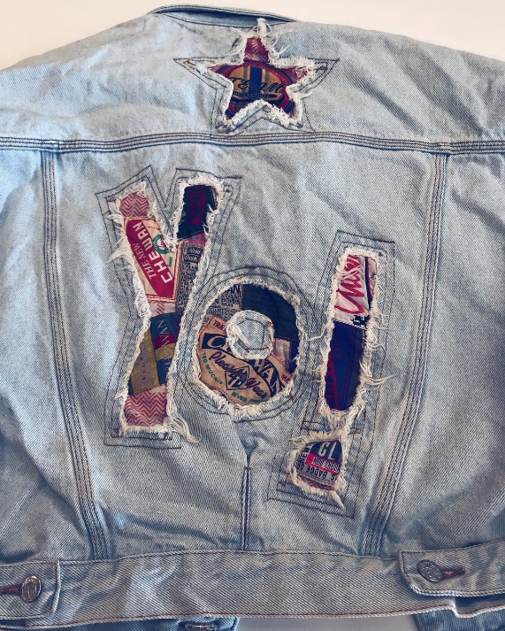

Source: https://www.instagram.com/hellovintagedk/

*Buying clothes can either be fun or a big pain in the.. pocket. So why not go the vintage-way? Especially when you get to enjoy the feeling of discovering the needle (aka “that cool jacket that fits you so well”) in the hay.*

**How does it work?**

We totally get you – not everyone is comfortable with wearing stuff used by someone else in the first place. Most of us are also very picky when buying clothes because we want to be unique that way.

However, being unique does not have to mean buying new and expensive clothes.

[Hello Vintage](http://hellovintage.dk/hello-vintage-2/) is an initiative whose purpose is to “take over all of Denmark with the vintage concept - and enrich you all with fashionable, unique and cheap clothes!” Basically, they are travelling all over Denmark, renting huge spaces for short periods of time and organizing large sells.

The concept is simple and straightforward: you go in the shopping hall, you dive into those 3 tons of vintage clothes and you pay for the exact weight of items you have chosen (yes, you pay per kilo, not per individual article).

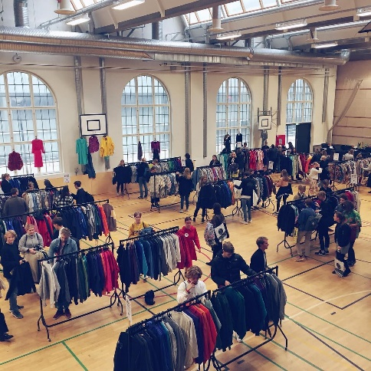 A picture containing person, outdoor, clothing, sky

Description generated with high confidence

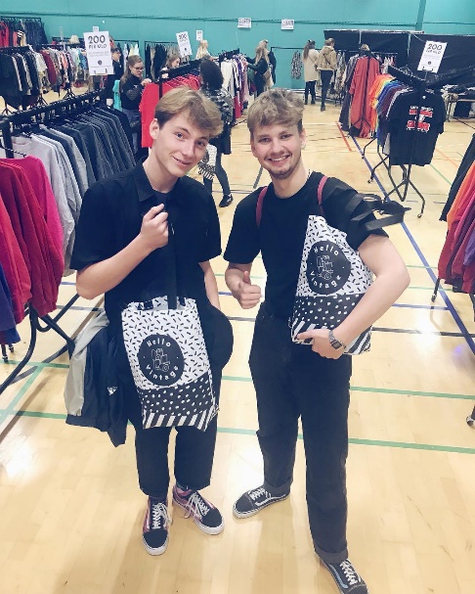 A person wearing a red shirt

Description generated with high confidence

**Forget about expensive clothing**

One important thing to remember is that you have to pay at the entrance no matter what. [Hello Vintage](http://hellovintage.dk/hello-vintage-2/) says that having an entrance fee allows them to rent the market halls and sell selected vintage items at affordable prices.

Speaking about prices:

* The entrance fee is **40, - per person** and kids under 12 years get free entrance. You can pay **cash** or by **mobilepay**.
* Clothing costs **200, - per kilo** (1 kilo = about 4-6 pieces of clothing).

A close up of a colorful blanket

Description generated with high confidence A girl in a pink shirt

Description generated with high confidence

All you have to do now is check their [calendar](http://hellovintage.dk/kalender-2018/) to see when their hitting your city, stay in touch with their [Facebook](https://www.facebook.com/hellovintagedk/?fref=ts) and [Instagram](https://www.instagram.com/hellovintagedk/) page or even check out their [blog](http://hellovintage.dk/blog/).

Facts on Hello Vintage:

* In the team behind it you will find experienced professionals with many years of work in the fashion industry.
* They are big supporters of sustainable shopping and recycling.

**Our tip:**

One of their favorite selling points is Godsbanen which is a really diverse cultural site. If you haven’t read our recommendation for that space yet, you can do it here (link).